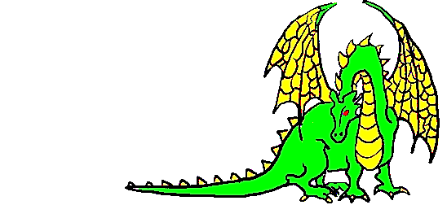
Unigames Membership
2018
Please print clearly
Name: _______________________________
□ UWA Guild Member
□ Unigames Fresher (First time member)
Student Number (If UWA): ___________________________
Email: ____________________________________________
(Leave blank if you want us to use your student email)
Phone Number: _________________________
Address: _________________________________________
_________________________________________________
(This will be used to hunt you down if you don't return our books/games)
Interests (tick all that apply):
□ Roleplaying games  □ Collectable Card Games  □ LARP  □ Attending Events  □ Reasonably-Priced Snacks | □ Boardgames  □ Wargames  □ Library Borrowing  □ Tactics Discount  □ Air-Conditioning
□ Email me about upcoming events
□ Email me about fresher campaigns
Sign: ___________________ Date: _________________
Administrative use only:
□ $3 O-Day Fee □ $5 Standard Fee □ $7 Non-Guild Fee
Gatekeeper: _________________________________

