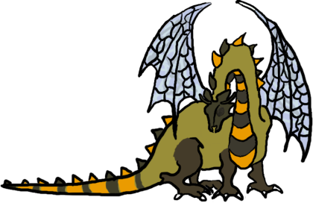
UniGames Gatekeeper Form
Gatekeepers should know:
- The Location of the clubroom
- Location of the board games cupboard, and the location of the magazine collection.
- Location of the Wargame terrain, Wargame books, and choose you own adventure novels.
- And the location of the keys thereof. (on the pink lanyard in the committee cupboard)
- Phone number of security
The Cupboard:
The cupboard is opened, with the combination lock. The code for which, all gatekeepers and only gatekeepers should know. The key lanyard should be locked in the cupboard, in the Advanced Stationary box. The cupboards should be locked with the bolt lock.
Clubroom:
As a gatekeeper you can open, and keep the clubroom open .
The clubroom should be only open if you are supervising it.
When you open the clubroom: take the money boxes out, turn on the lights, and make the clubroom inviting to anyone looking in. When you close the clubroom make sure that it is clean and tidy. No dice, food wrappers, drink cans, character sheets etc. spread across the table.
Looking after the clubroom is your responsibility.
If the bin is getting full, empty it. (There are skips at the back of Cameron Hall).
If the fridge is running low on drinks, fill it from available cartons.
If there are empty cartons in the fridge take them out.
Air Conditioner: The air con generates water. Particularly in humid conditions. When exiting the clubroom, please check and empty its bucket.
Speakers: Anyone in the room has the right to veto speaker use.
Money:
We have had serious theft, in the past, of food and money. Ensure money goes into the container, and notes go into the black note safe. Be aware that notes can be shaken out. Keep an eye on this. If people need change for notes then that is generally too bad. President, VP and Treasurer have access to the key to the note safe. Do not attempt to give people change from the note safe by violating it. Please, makes sure that people pay for the food and magic cards etc that we sell.
Library:
Gatekeepers, do look out for situations where books are likely to come to damage if you do not intervene. Eating and reading would be futile to enforce a ban on, but try to make sure it’s a calculated risk, the likely trajectories of fluids well away from pages etc. Hardcover Books left in the crooks of chairs are just waiting to be snapped.
Borrowing: As gatekeepers, you are responsible for the borrowing out and returning of library resources: (Books, Board-games, but not Dice). Please ensure a record is kept of all library resources removed from the clubroom; with the exception of resources being taken by Gatekeepers to use in the loft. Please speak to the Librarian.
I acknowledge and will uphold these guidelines.
Name___________________________________ Sign__________________________________ Date__________

