Unigames Camp 2017 Attendee Information Pack

This is the information pack for individuals attending Unigames Camp at Lake Leschenaultia on the following dates: Friday 30 June at 4:00pm to Monday 3 July at 10:00am

CONTENTS:
- Camp Contacts
  - Campsite information
  - Camp hall map
- Attendee Code of Conduct
- Packing List
  - Transport
  - Weather
- Camp Events
  - Event Participation
  - Arrival and Departure
- Menu
- Safety Information
  - First Aid
  - Alcohol
- Emergency Information
  - Medical
  - Police
  - Fire
  - Emergency Transport

1. Camp Contacts

Camp Leaders
Taylor Home
Unigames President
Phone: 0499 475 685
Email: loralogue@gmail.com

Gavin Tay Fernandez
Unigames Secretary
Phone: 0488 192 798
Email: tayfga15@gmail.com

Ben Slusarczyk
Unigames Treasurer
Phone: 0428 819 014
Email: benjaminslusarczyk@gmail.com

Head First Aider
Donald Sutherland
Unigames OCM
Phone: 0415 571 733
Email: donald@sutherland.id.au

1. a) Campsite Information
Unigames camp will take place at Camp Leschenaultia. This is the same location as Unigames’ previous four camps. It is about 45 minutes’ drive from the Perth city.
Address: 400 Leschenaultia Pl, Chidlow
Phone: (08) 9295 5444
Mobile: 0409 104 817
Campers will be sleeping in shared dorms. Women-only* and men-only* dorms will be available; other dorms will be shared. The dorms are equipped with bunks, but no sheets or pillows.
All activities will take place on-site.
The campsite does have a fire pit. Unigames will be complying with state laws and Camp Leschenaultia’s regulations regarding camp fires. Prior to use the area around the fire pit will be raked by a club committee member.

*The two dorms designated as gender specific are for any attendees who do not feel comfortable sleeping in a mixed-gender dorm. Non-binary attendees are welcome to use the dorms and bathrooms they feel most comfortable with. If you are concerned about other attendees questioning your choice of dormitory or bathroom, please contact a camp leader

1. b) Camp hall plan
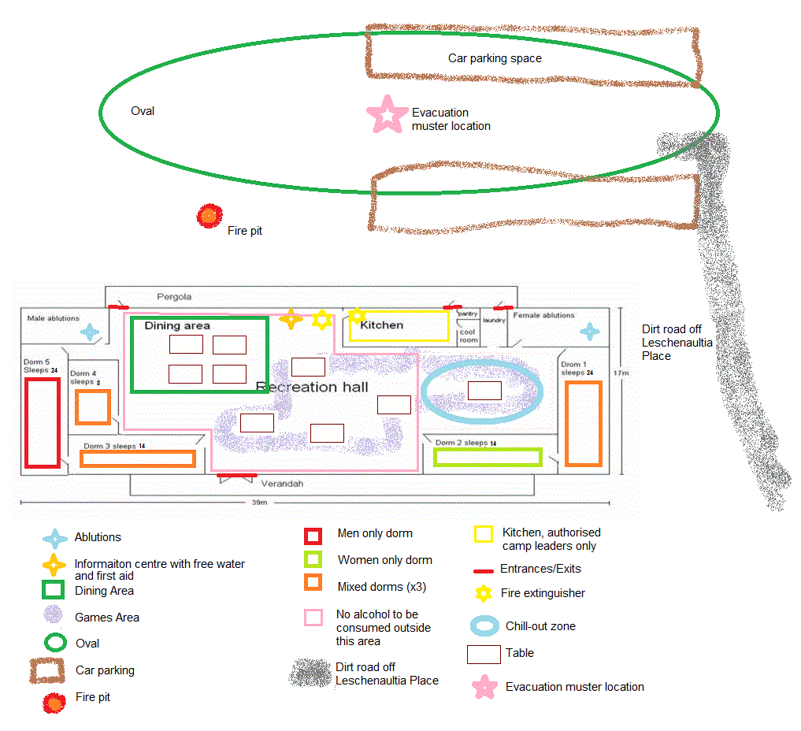

2. Attendee Code of Conduct

Behaviour:
- Attendees must not damage the property of Camp Leschenaultia or other attendees.
- In case of emergency, attendees should follow the instructions of camp leaders.
- Attendees should not participate in any behaviour that endangers the health and safety of themselves and other attendees
- Stealing, damaging, or failing to care for the property of Camp Leschenaultia, Unigames, or other attendees is prohibited*
- Bullying or acts of aggression and/or violence are prohibited.
- Possession or use of illegal substance on camp is prohibited*
Recreation:
- Any music must only be played inside the hall, and turned off at midnight each night.
Camp Fire:
- Attendees will not create fires in addition to the one already present at Camp Leschenaultia*
- Camp fire should not be left unattended by a Unigames Committee member.
- Attendees should not place plastic/glass/foam/metal objects in the fire.
Alcohol:
- Attendees may only bring beer, cider, wine, and pre-mixed drinks to camp.
- All drinks must be in original, sealed containers.
- Attendees are discouraged from bringing more than 11 standard drinks worth of alcohol, as there are limits on how much an individual will be allowed to consume per night.
- Attendees much hand over all alcoholic beverages upon arrival at the camp. Any drinks found un-surrendered will be confiscated by the camp leaders and approved manager.
- Drinks will be served back to attendees during designated drinking hours (18:00-0:00 Friday and Saturday, 18:00-22:30 Sunday), one at a time, by the RSA-trained bar staff.
- Alcohol may only be consumed in the common area, not in dorms, bathrooms or outside.
- Attendees must not drink and drive*
- Attendees will be refused the service of their alcohol if RSA-trained staff believe they are unduly intoxicated.
Breaches of Code of Conduct:
- Camp leaders will remind attendee of the Code of Conduct
- If behaviour persists, attendee will be asked to leave the camp
- Attendee’s emergency contact will be contacted
- Police will be contacted if necessary
- Camp leaders may assist with transporting attendee from camp

*Attendees are reminded that actions marked with an *asterisk* are illegal, and will result in the Camp Manager and the police being contacted, in addition to removal of offenders from Unigames camp. We recommend that attendees do not perform these actions at any time.
3. Packing List
Camp Essentials
- 3 days’ worth of clothes and underwear
- Jacket
- Sleeping clothes
- Socks
- Closed in shoes
- Thongs (for showers)
- Toiletries
  - Tooth brush, tooth paste, floss
  - Shampoo, Conditioner
  - Soap
  - Anti-perspirant
  - Face wash
  - Hairbrush
- Towel
- Pillow
- Sleeping bag and/or bedding (including fitted sheet for bed if you want)
- Magic cards
- Note books + pens for RPG-related needs
- Chargers
- Marshmallows
Other
- Torch
- Cash for purchasing snacks
- Your own snacks/food items
- Raincoat
- Extra socks
- Water bottle
- Board games/card games/rpg stuff
- Cold and flu/allergy/headache medication if required
- Prescription medication if required

3. a) Transport
Campers will need to arrange their own transportation to and from the camp. We recommend carpooling with other club-members. For help in finding people to car-pool with, contact Unigames in the clubroom, on the Facebook page, or one of the camp leaders via email.
3. b) Weather
It is likely to be very cold. Remember this when packing clothes and sleeping gear. Weather forecasts will be shared via email and the Facebook event prior to departure from Perth.

4. Events
Day/Time | Event
Friday/Evening  19:00 | Opening ceremony
Saturday/Morning  11:00 | LARP
Saturday/Evening  19:00 | Quiz night
Sunday/Morning  11:00 | Lara Croft Droft
Sunday/Afternoon  13:00 | Oneshots
Sunday/Evening  19:00 | Boardgames
Monday/Morning  10:00 | Leave camp

4. a) Event Participation
Attendees may opt-out of any event at any time. The camp sign-up form provides a place for attendees to, at their digression, inform camp leaders of any conditions (physical or mental) which could affect their involvement in our events.
4. b) Arrival and Departure
Camp attendees can arrive at the camp location from 4pm on Friday 30th June, and must leave the camp by 10am Monday 3rd July.

5. Menu
Food will be available on camp per the following menu. Attendees are welcome to bring any of their own food and snacks.
GF = Gluten free
V = Vegetarian
VE = Vegan
LF = Lactose free
Day\Meal | Friday | Saturday | Sunday | Monday
Breakfast | - | - Cereal (VE)  - Toast (VE) (LF)  - Gluten-free bread (GF) (LF) (VE)  - Fruit (GF) (VE) (LF) | - Cereal (VE)  - Toast (VE) (LF)  - Gluten-free bread (GF) (LF) (VE)  - Fruit (GF) (VE) (LF) | - Cheese toasties (V)  - Gluten free cheese toasties (V) (GF)  - Cereal (VE)  - Toast (VE) (LF)  - Gluten-free bread (GF) (LF) (VE)  - Fruit (GF) (VE) (LF)
Lunch | - | - Beans (GF) (VE) (LF)  - Eggs (GF) (V) (LF)  - Bacon (LF) (GF)  - Vegetarian bacon (VE) (LF)  - Bread/Gluten-free bread (GF) (LF) (VE)  - Green salad (VE) (GF) (LF) | - Sausages (LF)  - Vegetarian sausages (VE) (GF) (LF)  - Caramelised onion (VE) (GF) (LF)  - Bread rolls (VE) (LF)  - Gluten-free bread (VE) (GF) (LF) | -
Dinner | - Pasta (LF) (VE)  - Bolognese sauce (GF) (LF)  - Vegetarian sauce (VE) (GF) (LF)  - Gluten-free pasta (VE) (GF) (LF) | - Sausages (GF) (LF)  - Vegetarian sausages (VE) (GF) (LF)  - Roast veggies (VE) (GF) (LF)  - Bread rolls (VE) (LF)  - Gluten-free bread (VE) (GF) (LF) | - Pasta (LF) (VE)  - Bolognese sauce (GF) (LF)  - Vegetarian sauce (VE) (GF) (LF)  - Gluten-free pasta (VE) (GF) (LF) | -

Snacks available for free | - Bread (VE) (LF)  - Gluten-free bread (GF) (VE) (LF)  - Condiments (GF) (VE) (LF)  - Cheese (V) (GF) | - Fruit (GF) (VE) (LF)  - Cereal (VE)  - Tea and coffee (GF) (VE) (LF)
Snacks available for purchase | - Chips (VE) (LF)  - Popcorn (GF) (VE) (LF)  - Chocolate bars/blocks (V) (GF) | - Cans of soft drink (GF) (VE) (LF)  - Muesli Bars (VE) (LF)
6. Safety Information
Prescription Medication: Any prescription medication required is the responsibility of attendees. If you would like this to be stored securely while on camp, please contact a camp leader, however camp leaders will not be responsible for monitoring the administration of this medication.
If you require emergency medication, i.e. Epipen, you must be responsible for this, and keep it on you at all times. First aid officers may not be licensed to administer certain classes of prescription.
Upon signing up to camp attendees can fill out a medical authorisation form, giving camp leaders permission to administer emergency medication in a required situation.

6. a) First aid
A qualified first-aider will be rostered on at all times during the camp. Attendees may seek help from them in any situation.

First aid roster
Friday | Saturday | Sunday | Monday
Alaura | Taylor | Taylor | Alaura
Gavin | Donald | Tom | Donald

All camp leaders and Unigames committee members will be available to assist with any issues camp attendees have. An information centre will set up near the main entrance to the hall with relevant camp and emergency contacts, emergency information, and free water.

6. b) Alcohol
Unigames camp is an 18+ event and attendees may bring their own alcohol for personal consumption.
Upon arrival at the camp all alcohol will be collected from attendees, labelled and stored in a fridge. Upon request, and only during designated drinking hours, alcohol may be collected by the RSA on duty and served to its owner.
Drinking hours: 6PM to 12AM Friday and Saturday, 6PM to 10:30PM Sunday

RSA Roster
Friday Night | Saturday Night | Sunday Night
Ben | Gavin | Ben
Emily | Tom | Gavin

7. Emergency Information

7. a) Medical
In the case that medical assistance beyond basic first aid is required, camp attendees will be taken to the nearest hospital by a sober camp leader. The nearest hospital is Swan District Hospital.
If the situations requires, an ambulance will be called.
Swan District Hospital: 9347 5244
Eveline Road, Middle Swan 6056
Ambulance: 000 (112 for mobile)

7. b) Police
If any person on the camp grounds is breaking the law, or refusing to leave post non-compliance with Unigames or Camp Leschenaultia regulations, the police will be contacted.
Police (emergency/attendance): 000 (112 for mobile)
Police (not emergency): 9290 1900

7. c) Fire
Fire Response: 000 (112 for mobile)
Emergency Evacuation:
In the case of a fire, Unigames committee will commence Camp Leschenaultia’s fire evacuation plan.
- Use fire extinguisher if safe (location marked on hall map)
- Dispatch person to call 000 and inform Camp owner
- Shout “FIRE FIRE FIRE”
- Meet outside in front on the dining area on the oval
- Camp leaders to ensure dormitories and toilets are cleared and to account for all campers.

7. d) Emergency Transport
In the case that a camp attendee must be removed from the camp for reasons pertaining to the camp rules, the law, or a medical situation, the attendee’s emergency contact will be contacted.
Attendees’ emergency contact cannot be an individual also attending the camp.
If the attendee’s emergency contact cannot be reached a sober camp leader will be available to drive the attendee to appropriate public transport services, or home.

