Cameron Hall Quiz Night Team: ________________

- Caption the following stock images with clickbait headlines:
 | 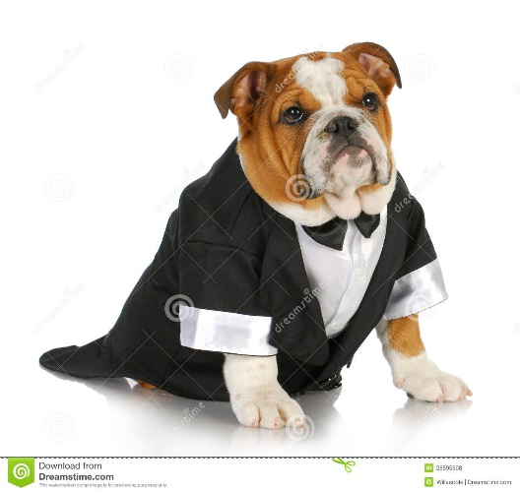
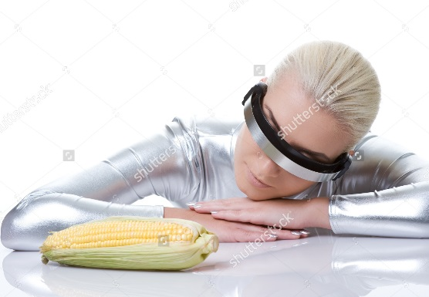 | 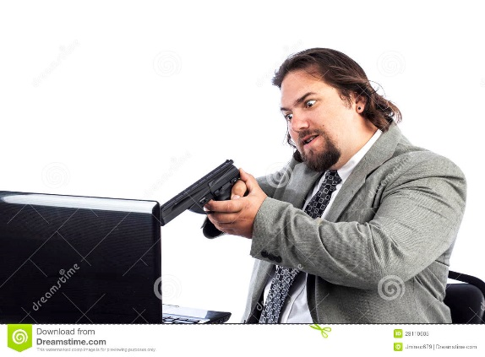
- Write a review of the Cameron Hall logo:
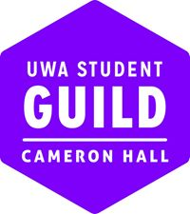

Cameron Hall Quiz Night Team: ________________

- Draw the hosts:

- Create a fresh meme:

