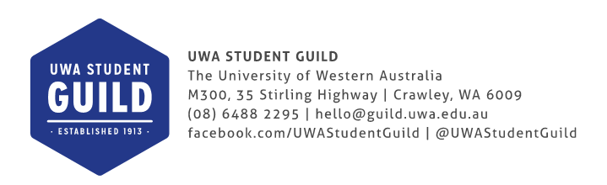
BEST CLUB
AWARD

CLUB NAME: Unigames
NAME AND POSITION OF NOMINATOR: Sarah Lewis, Unigames President
PHONE NUMBER: 0409 658 665
EMAIL: 21301124@student.uwa.edu.au

WHAT IS THE BEST CLUB AWARD?
Each year, the Societies Council (SOC) provides an award for the best performing SOC affiliated club. This is to provide recognition for all the hard work and success clubs have enjoyed throughout the year. It also provides clubs an incentive to continue improving year to year and strive to be the best they can. The Best Club Award is presented at the Guild’s Annual Cruickshank-Routley Memorial Ball, with the award being valued at $1000.

BEST CLUB CRITERIA

The winner of the Best Club is determined by the SOC Committee. The criteria on which the Best Club Award will be judged are as follows:
- Achievement of club aims and objectives
- Involvement in Guild events (e.g. O-Day, PROSH, PROSH Olympics, Club Carnival, Relay@UWA) and the wider university community (e.g. other clubs, residential colleges, faculties, Guild Volunteering Hub).
- Successful engagement with club members
- Demonstrated responsible event management and planning
- Attendance at SOC meetings
- Other outstanding accomplishments, achievements or involvement (e.g. charity work, volunteering, awards, community involvement).

HOW TO APPLY

To apply for the Best Club Award, clubs must submit a written application addressing the criteria listed above by the closing date as specified by the SOC President. Applications should comply with the following:
- Include a completed Best Club Award Application Coversheet
- 10 page maximum, excluding coversheet
- Be submitted via email in PDF format to soc@guild.uwa.edu.au
- May include any photos and publicity material in support of the application

For any queries relating to the Best Club Award, please contact the SOC President at soc@guild.uwa.edu.au.
Unigames (not the sports one) Best Club Application
Sarah Lewis
Unigames President 2015
Table of Contents
Achievement of club aims and objectives: 3
Involvement in Guild events: 4
O-Day and Club Carnival 4
PROSH 5
Relay for Life 5
Role-Play for Life 5
Other Unigames Events: 6
Escape Hunt 6
Camp!!! 6
Cameron Hall Quiz Night 8
Cameron Hall Masquerade 9
Cameron Hall Charity Vigil 9
Cameron Hall Un-charity Vigil 10
Responsible event management and planning: 10
Attendance at SOC meetings: 10
Other cool things: 11
Collaborative Events 11
Sponsors 11

Achievement of club aims and objectives:
Our primary Constitutional objective is to facilitate the playing, design and production of tabletop games. This year we have been in a pretty much constant state of completing our objective with many games, including board games, card games, and role-playing games, being played almost every day. We even went outside for some of them.
Throughout the university semesters there were board games nights, Magic Drafts and role-playing one-shots every week or two, and a few war-gaming meet-ups. Club members also utilized our resources and ran, on average, at least one role-playing campaign each week night during semester, resulting in a large number of club members being involved with the club in some way.
Unigames’ board games events and RPG one-shots are always free, and are held on different week nights across semesters and during breaks so that different people are able to attend. The majority of our income is spent on games and RPG books for use by club members; this year we spent over $4000 on game resources. Unigames runs a library so that our members can access our resources for free! Items can be used in Cameron Hall, or borrowed and taken off-campus for short-term periods of time.
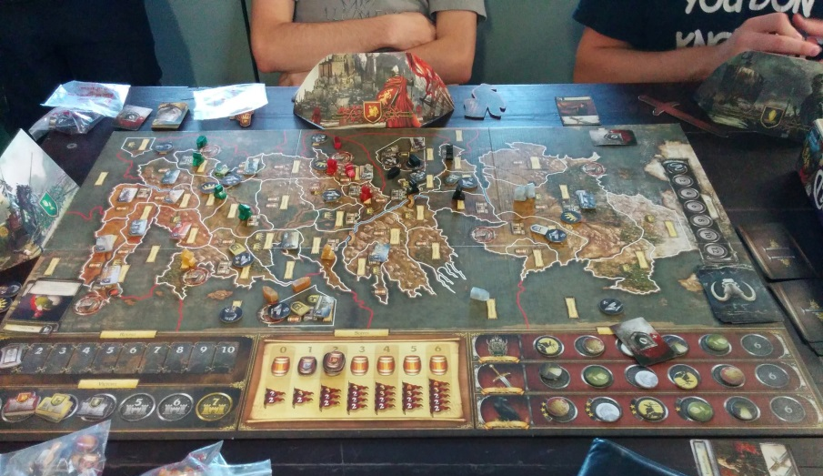
The game of Game of Thrones: for when Risk just doesn't tear your friends apart like it used to.
Since some RPG books are very specific to a particular game system and unlikely to be purchased by the club, Unigames offers to cover half of the cost of such items for members who would like to purchase them. This club regulation is used a few times a year by individuals or groups, and supplements the club’s huge range of table-top resources.
This year Unigames became sanctioned by Wizards of the Coast allowing us to run official Magic The Gathering events. We were able to run our first official Magic Pre-releases in the Cameron Hall Loft in association with the Perth gaming store Tactics. We provided official Magic events, including drafts and prereleases, (which are usually hella $$$), to our members at the lowest cost possible. We also sell single packs of Magic cards to our members at the cheapest prices in Perth.
People are found in the Cameron Hall Loft playing magic every day of the week. Unigames has spare cards and pre-built decks which club members can borrow at their leisure.
Here are some short descriptions of important things:
Role-playing games (RPGs): games in which players will describe their character’s actions through speech. How well or badly a character preforms these actions can depend on luck-based decision making systems which most commonly involve rolling dice. RPGs can be played as long-term campaigns where players meet up every week or so to play a session, which can be thought of as ‘episodes’ in a TV show.
Game-Master (GM): like a story-teller, they are the individual running the RPG. They will describe the environment the players are in and act as the non-player characters and monsters in the game.
One-shot: a format for RPGs that take place over one game session, instead of over multiple sessions like in a campaign. These games only take around 5 hours and are great for new players to try different RPG systems, and for players who cannot commit to weekly meet-ups.
Magic The Gathering (MTG): A card game that is like Yu-Gi-Oh but better. It also requires believing the heart of the cards. MTG is popular all over the world, and can be played in ‘standard’ tournament formats or casually. Unigames plays them all.
Magic Drafts: A format of MTG that allows players to create new decks and play in a mini-tournament. The prizes are generally more MTG cards.

Involvement in Guild events:

O-Day and Club Carnival
In 2015 Unigames had a stall on O-Day and at the Semester 1 and 2 Club Carnivals. Over the year, but primarily during these events, we signed up 230 financial members, which is more than we have had in recent recorded history! (and very probably ever!!!)
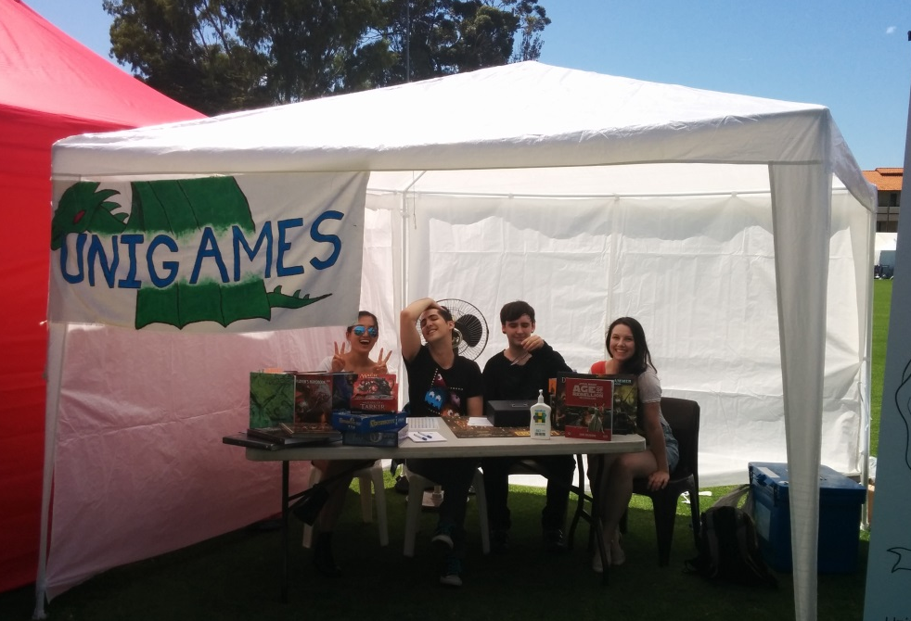
Is it hot out here or is it just- wait no, it's not just me. It's always hot on O-Day.

PROSH
Unigames ran our first PROSH event with the dress up theme 'Star Wars: Edgier Empire', which allowed club members to have a traditional or more modern (see: bathrobes) take on their dress-up. The theme also piggy-backed off the popularity of the new Star Wars role-playing game: Edge of the Empire. Due to a lack of other Cameron Hall club PROSH teams, we invited members from UniSFA and UCC to join us.
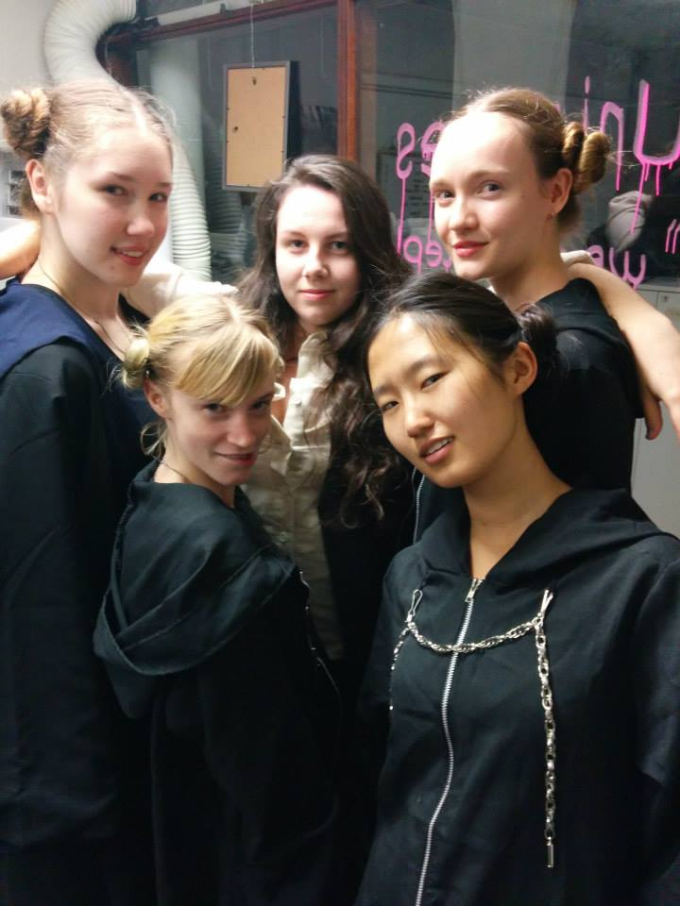 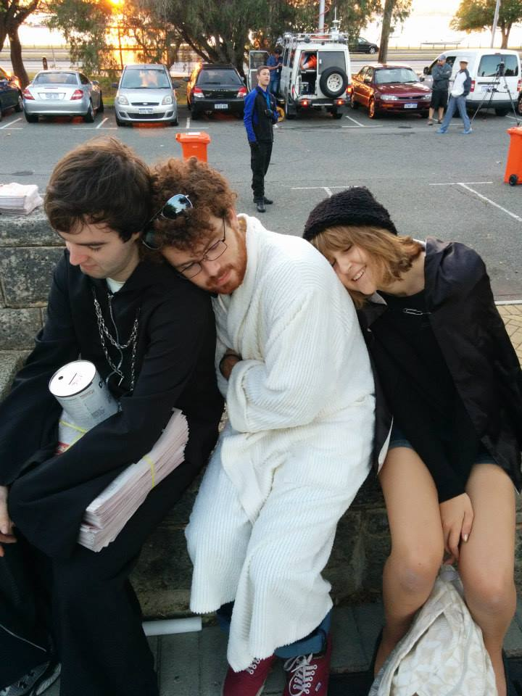
We had so many Leias. Now I can die happy.

Relay for Life
Unigames also participated in Relay for Life for the first time this year. We had a team down at the pre-relay event (should have been called PRelay) where they got absolutely wrecked by the contending FacSocs. In preparation for the actual Relay, our team UniGains hit the max capacity for a Relay team (which honestly I didn't know existed until I got the email) in August. With a month and a half until the actual Relay, everything had already gone better than I could have hoped.
To create more 'hype' for the sports, Unigames and UniSFA's club members have been donating to the 'Battle Tin,' which is a Relay donation tin shared by the two clubs, the contents of which will be added to the fundraising total of the team which runs the most laps. I'm pretty confident that it will be us.

Role-Play for Life
Our major fund-raising event for Relay for Life was a new event: 'Role-Play for Life'. This event saw 2 different table-top role-playing games run for 24 hours straight. The players were switched out every six hours so they could study or catch an Uber home to sleep, but the GMs were fueled by coffee and weird nerdy determination to last the 24 hours. The event was far more popular than we expected, (it turns out our membership doesn't prioritize study and having regular sleep patterns as highly as I thought,) and we had enough players tagging in and out to keep the games alive and the GMs awake.

Other Unigames Events:

Escape Hunt
Off-campus Unigames ran two successful events with Fremantle Escape Hunt. We were able to provide $25 tickets for our members to complete all three of Escape Hunt’s different puzzle-rooms, when it would usually cost over $30 per person to complete just one.
Escape Hunt’s puzzle-room experience sees groups of 3-5 people get ‘locked’ into a room where they must solve multiple different puzzles in order to solve the room’s mystery and ‘escape’. Anything else I say would be spoilers, but everyone who went said that it was amazing! Unigames is staying in regular contact with Escape Hunt, who are eager to let us know when they change their puzzle-rooms so that those who completed their old rooms can return for new activities!
The events were fantastic for getting club members to engage with each other in small groups, and are a great addition to our club’s regular activities due to their emphasis on team-based problem-solving.

Camp!!!
Our Major event of the year was the camp held over the winter break. 44 club members came to Camp Leschenaultia for the 3-day event. The event had a full agenda of events including a quiz night, and a LARP, which were both adequately referent to the event's theme 'Bards and Barbarians'. Board games, RPG one-shots, and card games were played during the free game time over the weekend. And there may have also been karaoke. Camp is a great event for club members to meet and engage with a much larger group of people than would generally be at any one of our smaller events throughout the year.

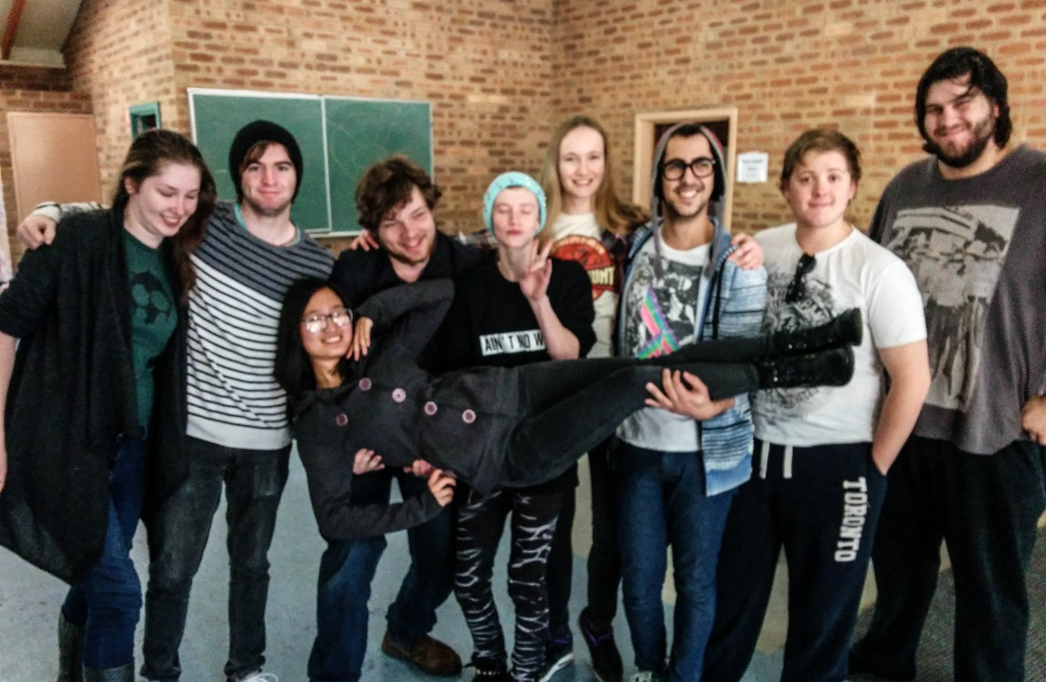
Since Ruisi carried the team a whole lot re: mopping, we thought we'd return the favour.
LARP: short for ‘Live Action Role-Playing’. A LARP generally involves participants physically acting out a character’s actions and engaging with the physical world to complete activities. For example; ‘bards’ would actually sing, and barbarians would actually wield pool noodles and bean bags in ‘capture the flag’ style scenarios that are not entirely unlike regular sports. LARPS are good for fulfilling one’s annual vitamin-D requirements. We made sure to provide heaps of sunscreen.
Freestyle poetry and drawing competitions were incorporated into the Camp’s quiz, so that the less-physically inclined participants could engage their inner bards. Some of the material they created was fantastic, and coincidently, Unigames now has a new banner design.
This year was Unigames’ third annual camp, and despite aiming to break even, we made a profit! As a club which has experienced financial difficulty in the past and generally runs events that do not charge for entry, this is a great success and means that we can confidently continue to run camp every year. The camp’s operation was without issue, all committee members and RSA volunteers undertook their responsibilities extremely well, and the food was actually pretty good.

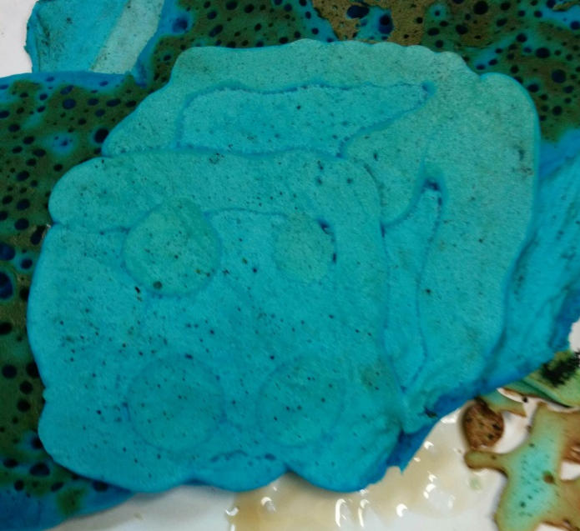
This pancake is blue and shaped like a dice. Are we allowed to do this? I hope we're allowed to do this. Anyway, like I said, the food was fine.

In 2015 Unigames also collaboratively ran the Cameron Hall Charity Vigil, the Un-charity Vigil, the Cameron Hall Quiz Night and the new Cameron Hall Masquerade.

Cameron Hall Quiz Night
The Quiz always has a high attendance and is a very popular event for members of Unigames, UniSFA and UCC. Approximately 12 tables of guests attend each year to answer many rounds of questions which will undoubtedly include “What was Sir Donald Bradman’s batting average?” until the year that all the tables get it right. This year was not that year. The inspired 'Tony Abbott' round made its second appearance at this year's quiz, and a troublingly large number of people were able to answer the question "how many calories in a brown onion?'
Prizes are generously donated by the three clubs’ sponsors. Unigames’ Tactics, Good Games Cannington and White Dwarf Books provided some great nerdy loot. Prizes are collected during a ‘sponsor crawl’ which encourages UniSFA and Unigames members to tag along on a group shopping trip where the clubs and members can support the businesses which support them!
The Quiz is great for strengthening the sense of community shared between UniSFA, UCC and Unigames. The membership crossover between the three clubs is large, and our club rooms and wider community are so beneficial for club members who are able to meet different people and try new hobbies in our supportive environment.

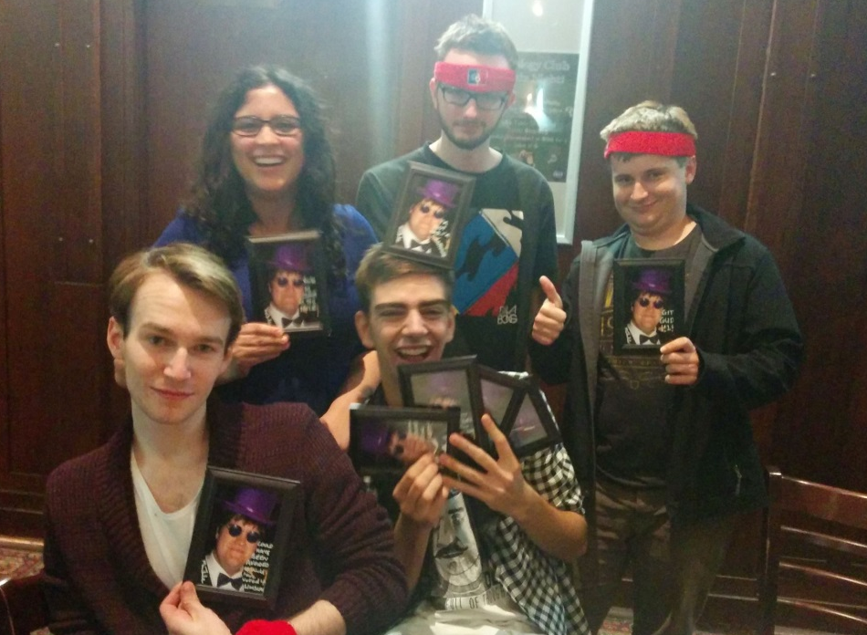
The lucky team who came in at last place with their sweet prizes: photos of the head quiz organiser with 'personalised' motivational quotes such as "It’s the thought that counts” and "git gud".

Cameron Hall Masquerade
The Masquerade was a new event run by the same three clubs in an attempt to provide a cocktail-like event for members of Cameron Hall clubs. The event was held in the Tav and ticket prices were kept down at $20 to make the event accessible. Honourable mention to EMAS for being great DJs: they played actual good music at first, and caught on quickly when the trashy pop requests started coming in. Despite our lack of experience running cocktail events, the attendees had a great time. We plan to run the event again next year, also inviting more extended Cameron Hall clubs such as UWASCA, UWAnime, and Pantomime Society.

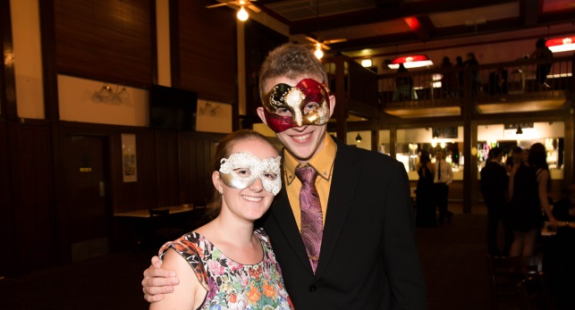
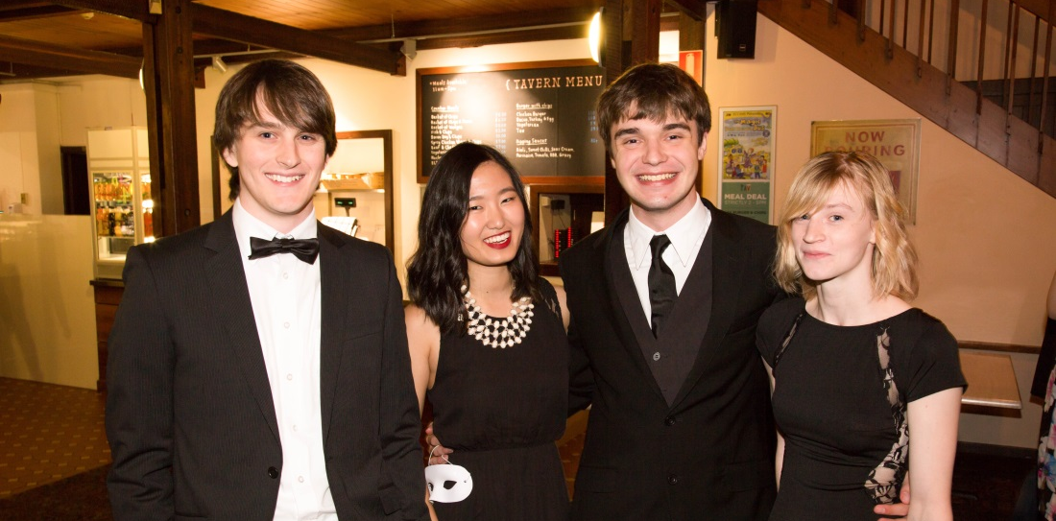
They scrub up alright.

Cameron Hall Charity Vigil
In Second Semester Unigames led the organisation of the annual Cameron Hall Charity Vigil with UCC and UniSFA. This year UWA Pantomime Society joined the event and provided their own activities that ran in conjunction with our one-shots, board games, movie screenings and UCC's LAN. On one hand, the event raised over $1200 for the charity Youth Focus. On the other, it saw a group of 5 lose the team-based zombie apocalypse board game, Dead of Winter, for the first time since we bought it. Get good plz.

Cameron Hall Un-charity Vigil
The Un-charity Vigil was created to pull Unigames out of financial hardship a few years ago. It worked, and now the event runs primarily to provide members of Unigames, UCC and UniSFA a large group event at the end of the Summer holidays. Members are encouraged to participate in the range of events provided by the three clubs, which are essentially those at the Charity Vigil, minus the integration of multiple donation opportunities.

Responsible event management and planning:
Unigames has committee meetings every week which are always attended by a majority of the 9-member committee, and are open to any other club member who wishes to provide suggestions or help out. Cameron Hall busy bees are always attended by Unigames committee members. Our committee members also take responsibility over the condition of Cameron Hall’s communal loft, as it is a useful place for our members to play games.
Despite not charging entry to a majority of our events, we have been able to maintain stable club funds by selling drinks, snacks and MTG cards at events, and by making profits on bulk pizza orders at our many games nights. Despite being cheaper than other official MTG events in Perth, our drafts and pre-releases also make small profits. An absolute of our income goes straight back into events, resources and consumables for our members.
Our largest and most planning-intensive event was camp, for which we had to implement a secure alcohol management strategy in order to allow attendees to enjoy their own beverages while minimizing the many risks involved with having alcohol at events. Our extensive planning of procedures and emergency actions meant that we were able to successfully run our event confidently, with secure processes in place for emergencies. All attendees understood and complied with our alcohol regulations, no one got absolutely trashed, and I didn't have to clean up any vomit.
The guild’s leadership/event/camp training was undertaken by 4 of Unigames’ executive committee members and was extremely valuable in assisting us to run a functional, safe event. The training helped us to establish a friendly atmosphere at camp which didn’t encourage heavy drinking or recklessness. This will impact future events as these expectations of atmosphere and behavior remain associated with our events, and help to reinforce our club’s image as open, engaging and safe. We maintain an active social club without relying on alcohol, which is absent from a huge majority of our events.

Attendance at SOC meetings:
A Unigames committee member attended every SOC meeting this year. Our President attended more than half the meetings, with the Vice President, Treasurer, and Secretary attending all others. We have particularly benefitted from the presentations about marketing, especially online, and are extremely interested in the introduction of online EMPs and MyGuild. Unigames is always working to improve our visibility on campus and we think that the online calendar and shout-outs in Guild Weekly will help to make us more accessible for students.

Other cool things:

Collaborative Events
During the year we also ran some collaborative board games evenings with the Queer Department, St Catherine's College, the Arts Union, the Music Student Society and UWA Bi The Way. We're hoping to keep these relationships alive, and reach out to other clubs, colleges, and FacSocs in order to share our resources with as many people as possible while getting our club's name (and the fact that we actually exist) out there to the student body! Collaboration on these kinds of events is easy for Unigames as we have so many great resources that can be easily brought to events help with or by other clubs.
The second Escape Hunt event was run in collaboration with UWA Pantomime Society. Both clubs had a large and equal turn out. Unigames will be aiming to run this collaborative event with PantoSoc again, or other clubs, colleges and FacSocs next year. Escape Hunt is eager to extend their discount offer to other groups who would benefit. You guys should come too. It's honestly pretty cool.
Unigames runs many events every year with UCC and UniSFA and believe that the three clubs provide a great community for students with slightly (or extremely) nerdy interests to meet a wide range of people and even expand their own hobbies. This year Unigames drafted some inter-club regulations for our own committee members to bring to the inter-club event committees to ensure that the events are run effectively and with participation from all clubs. These guidelines have helped to organize the event committees and monitor their progress, and have led to results that all the involved clubs are satisfied with.

Sponsors
Unigames is sponsored by Perth Gaming stores Tactics and Good Games Cannington, as well as White Dwarf Books. We provide club members with information about our sponsors in our club room and online, and distribute their cards at events such as the Cameron Hall Quiz Night and Charity Vigil.
Tactics gives Unigames members a 10% discount in store, which is fantastic as hobby books and materials are very expensive, especially in Perth. Tactics will also give the club larger discounts when we make our big semester bulk-purchase, and donate a collection of prizes for the Quiz and Charity Vigil.
Good Games give us fantastic deals on prizes for the Quiz and Charity Vigil, whereby we’ll pay for one or two large items, and they will give us a great deal more small prizes as a donation.
White Dwarf Books provides members with a 10% discount on their sci-fi and fantasy books which can be used as resources in RPGs, or for reading.
Our relationships with Tactics and White Dwarf Books have lasted over 5 years and are only getting stronger as the club is now extremely financially stable and can afford to give them as much support (in the way of buying our resources from them) as they have always given us!
Chessex, a company which supply dice and other game materials to resellers, also gave Unigames a huge discount this year on a bulk order. We ordered supplies for the club, as well as took orders from individuals. We have established a relationship with Chessux after a similar exchange in 2011, and will be able to supply materials to the club at prices much lower than that of local resellers.

