Dear Potential Sponsor,
The Cameron Hall Charity Vigil is a long running charity event, run by clubs at UWA.
It is dedicated to raising money for local charities that help the young people in our state.
This year we are supporting Youth Focus.
Youth Focus aims to put a stop to youth suicide.
We are a unique independent not for profit organization that supports vulnerable young people in Western Australia by offering a range of mental health services. We operate with a team of highly trained and skilled psychologists, social workers and occupational therapists to provide a range of early intervention and prevention services free of charge, aimed at supporting young people and their families to overcome the issues associated with suicide, depression and self harm.
Youth Focus currently helps thousands of people each year through counseling and education programs. If you have any questions about Youth Focus, take a look through their website at http://youthfocus.com.au , or feel free to phone me with any additional questions.

The Cameron Hall Charity Vigil is traditionally attended by up to 200 of our members.
It is a night of LANs, board-games, and movies. Attendees collect money before the event. This money is collected up at the event, then added to what we can raise on the night, though raffles and the sale of soft-drinks and food. This year it is being held on the night of Friday 3/10, through to the next morning.
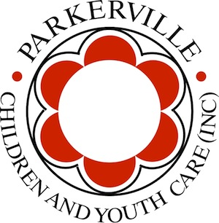




Each year we aim to make this a more successful event, and this year alongside getting more clubs involved, we are aiming for a much larger attendance, making it a great advertisement opportunity!
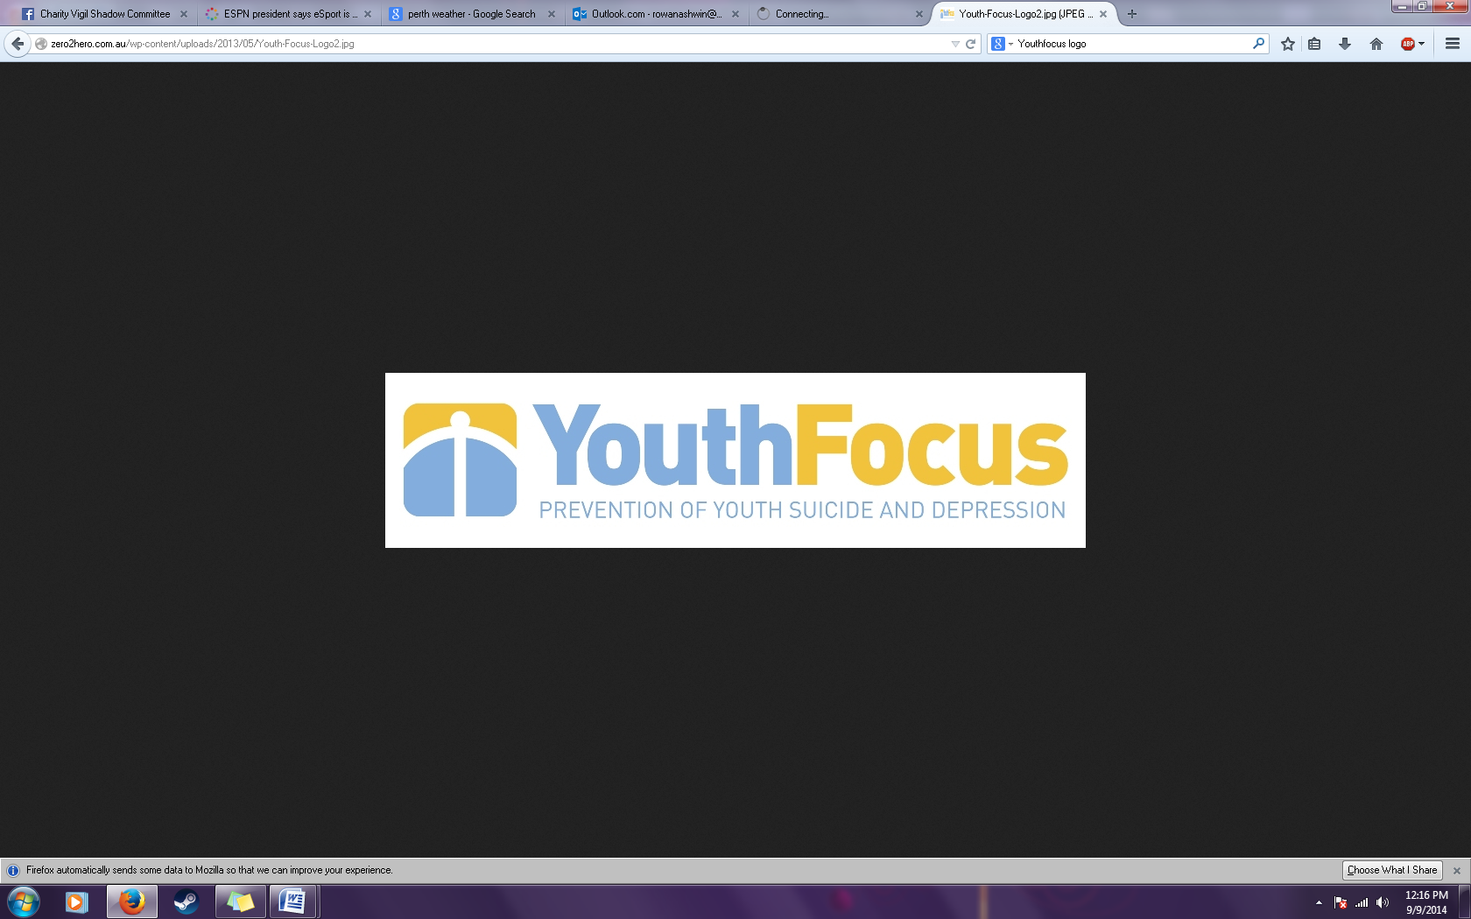
This year the Cameron Hall Charity Vigil has set a goal to raise over $2000. Towards this end we are seeking sponsorship in the form of:
- Food, or discounts to food: to allow us to cover dinner and breakfast at the event.
- Prizes, allowing use to run silent auctions, raffles and door prizes.
- Direct monetary sponsorship: tax deductable; cash, cheque or EFT accepted.

As a sponsor of the event you would benefit by:
- Having your name and logo on our posters around UWA
- Having your name and logo on the forms our members take around to collect donations.
- Having your promotional material presented and distributed on the night.

If you have any questions, about the Charity Vigil, or about Youth Focus,
please do not hesitate to contact me.
Thank you
Rowan Ashwin
Cameron Hall Charity Vigil Chair 2014
Ph: 0451 141 269

