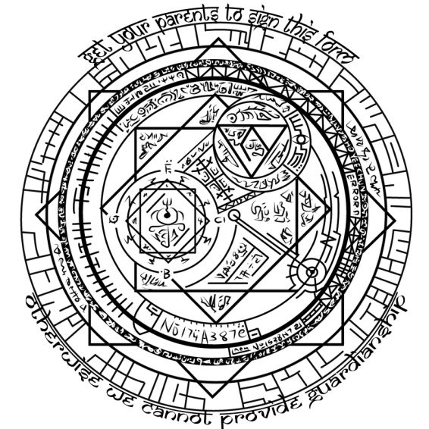
WIZARD CAMP
PARENTAL CONSENT FORM

By signing here, you (full name), ___________________________ confirm that as you will be under 18 at the time of ‘Wizard Camp’ (5th to 8th of October 2013), you have sought consent from your current legal guardian over attendance of this event, and their signature will feature on this form in the correct field when it is received by Unigames.

ATTENDEE PLEASE SIGN HERE: ____________________________ DATED __/__/2013

By signing here, you (full name), ________________________________ give consent for the attendee whose signature will feature on this form when it is received by Unigames to attend ‘Wizard Camp’, and confirm that you are their current legal guardian.

PARENT/GUARDIAN,
PLEASE SIGN HERE: ____________________________ DATED __/__/2013

