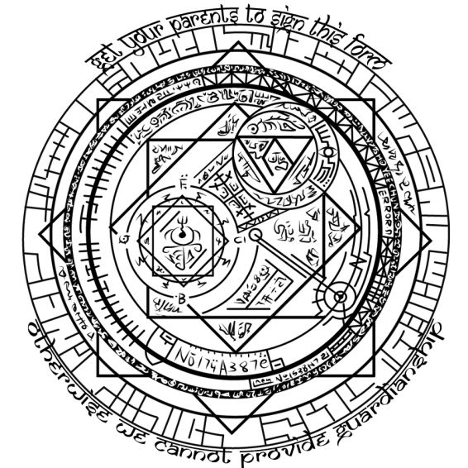
WIZARD CAMP
EXPANDED PERSONAL LIABILITY WAIVER

(Image above is purely decorative)
It is the intention of (full name)_________________________________________, by this waiver to exempt and release the University of Western Australia, the club organisation Unigames, and their representatives from any liability or responsibility for personal injury, property damage, and wrongful death associated with the activities of these organisations spanning from the 5th of October 2013 to the 8th of October 2013.
I understand that while Unigames will endeavour in some ways to provide a safe environment free of these risks, I hold ultimate responsibility for my own safe conduct.
I understand and confirm that by signing this waiver I have given up considerable future legal rights. I have signed this agreement freely, voluntarily, under no duress. My signature is proof of my intention to execute a complete and unconditional waiver of all liability to the full extent of the law. I will be 18 years of age or older by the time period specified and thus capable of being my own legal guardian during these activities; or I have sought my current legal guardian to provide consent for my attendance, and their signature appears on this form.

ATTENDEE PLEASE SIGN HERE: ____________________________ DATED __/__/2013
For Attendees under 18:
By signing here, you (full name), ________________________________ give consent for the attendee whose signature will feature on this form when it is received by Unigames to attend ‘Wizard Camp’, and confirm that you are their current legal guardian.

PARENT/GUARDIAN,
PLEASE SIGN HERE: _______________________________ DATED __/__/2013

