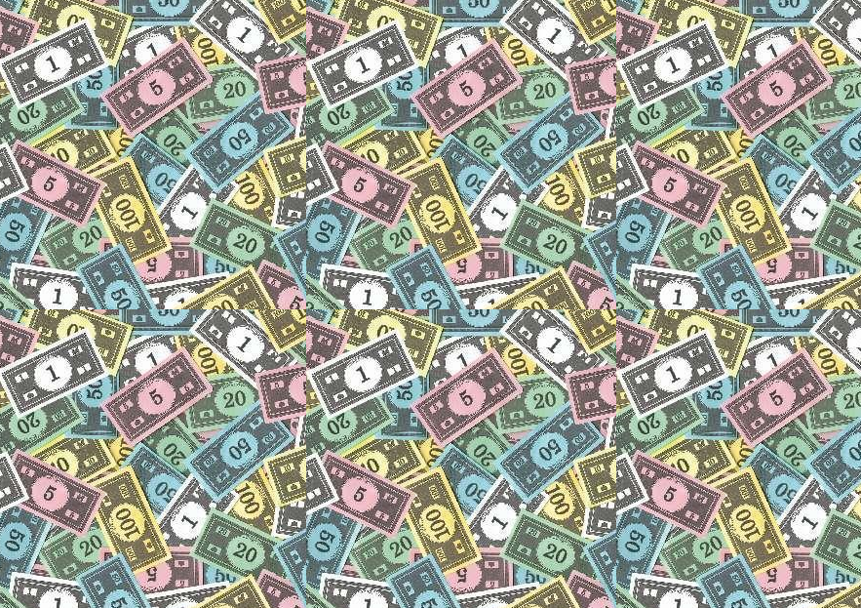
Board Game Event
Special Price List

Water $0.50
Community Chest: $5.00
- 1 packet of Chips,
- 1 jar of salsa
I can Has Toucans?: $1.50
- 2 cans of drink
It is the funding from our memberships that allow us to purchase these games, and to run events such as this.
If you would like to become a member of the club, or if you haven’t payed your membership fee’s this year, please speak to a committee member.
Note: game money is Not legal tender.
Also another reminder, if you want any books bought get in contact with the librarian ASAP, so committee can discuss this.
kerrr04@student.uwa.edu.au

