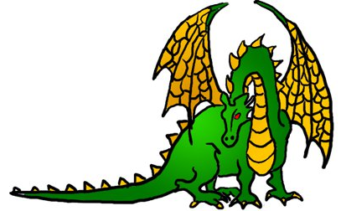
Unigames Membership
Name:________________________________ □ UWA Gold Guild Member
Student Number (If UWA) ________________
Phone number: ________________________ Address:______________________________
______________________________________
(This will be used to hunt you down if you don't return our books)
Interests (tick all that apply):
□ Roleplaying games  (dnd, nWoD, DH etc) | □ Wargames  (WH40K etc)
□ Board/card games | □ collectable card games (MTG etc)
Are you interested in borrowing from our Library (of books, and boardgames) □
Sign:___________ Date:___________
Committee member: ____________________

