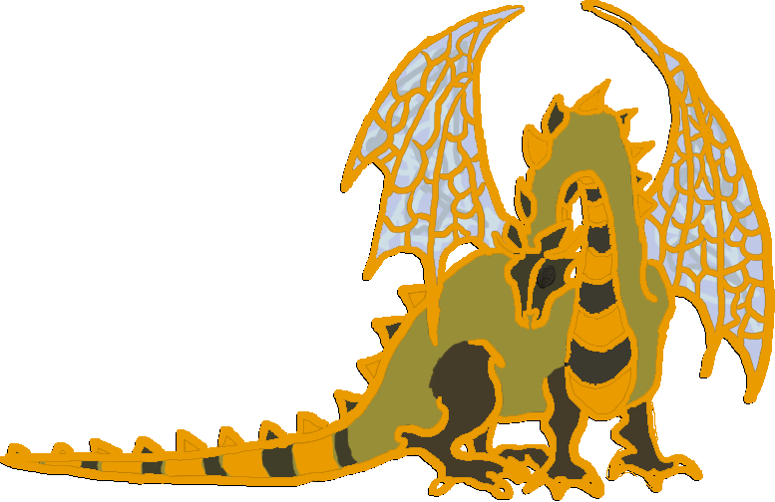
Cameron Hall
Busy-Bee
Guild Provided Sausage Sizzle Lunch
Then:
Board Game Arvo
WE HAVE NEW GAMES
2pm, Sunday 17th April.
or whenever we finish the Busy Bee.
Pizza Dinner, via pooled money for pooled Pizza. People who come alone to Busy bee, Unigames Subsidized Pizza.

New purchases:
-Dominion
-Small world
-Arkham Horror
-Robo Rally
Games no one has heard of:
-Doom
- Things i don’t bother to remember
Old favorites:
-Chaos in the Old World
-OOTs
-Munchkin
-Talisman
-Settlers of Catan

Classics:
-Chess
-monopoly (and antimonopoly)
-Risk (in more than a few variations)
-Master mind

