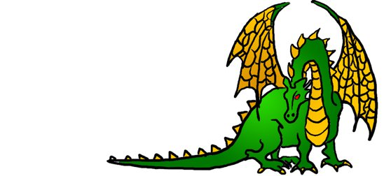
UniGames
GateKeepers
Gatekeepers should know:
- The Location of the clubroom
- Location of the board games cupboard, (in the hall)
- Location of the Wargame terrain, Wargame books, and choose you own adventure novels. (upstairs)
- And the location of the keys thereof. (on the pink lanyard in the committee cupboard)
- Phone number of security
The Cupboard
The cupboard is opened, with the combination lock. The code for which, all gatekeepers and only gatekeepers should know.
The cupboard has three shelves.
top shelf: peoples personal possessions, primarily war-game Armies, and the painting equipment for them.
Middle shelf: Committee stuff, library forms, and the Advanced Stationary box. The Cashbox is also found here.
Do not under any circumstances, ever open the cashbox, there is nothing of interest there, Keep moving.
Bottom shelf: Magic cards, and related paraphernalia. These are for sale. You should be aware of the prices of these.
Locking the cupboard: the key lanyard should be locked in the cupboard, in the Advanced Stationary box. The Cupboard should be locked with the bolt lock at that bottom, and the chain pulled tight. This also goes for our other cupboards that are locked in similar fashion.
Clubroom:
As a gatekeeper you can open, and keep the clubroom open (obviously). This give you some responsibilities.
The clubroom should be only open if you are supervising it.
When you close the clubroom make sure that it is clean and tidy. No dice, food wrappers, drink cans, character sheets etc. spread across the table.
Looking after the clubroom is your responsibility:
If the bin is getting full, empty it. (There are skips at the back of Cameron Hall).
If the fridge is running low on drinks, fill it from available cartons.
Please, makes sure that people pay for the food we sell in the clubroom.
Library:
Gatekeepers, do look out for situations where books are likely to come to damage if you do not intervene. Eating and reading would be futile to enforce a ban on but try to make sure it’s a calculated risk, the likely trajectories of fluids well away from pages etc. Hardcover Books left in the crooks of chairs are just waiting to be snapped.
Borrowing: Every time anyone wishes to bring a book (or other club resources) outside Cameron Hall, they must acquire a borrowing form and fill it out, of particular importance being who has it obviously, the name of the book (Sticker colour is important), but gatekeeper signatures are also vital, as well as the date it was borrowed on. Other details are greatly appreciated but those are the most vital fields. If the person in question is a gatekeeper ideally they should seek another gatekeeper for this authorisation signature. After this, the form should end up in the Librarians hands somehow: If they aren’t around, it must be placed in the cupboard adjacent to the stack of new forms, bulldog clipped to any other on loan forms.
To Apply for Gate Keeper: please contact a committee member, and it will be discussed at the next committee meeting.

